**Bug Report**

|  |  |
| --- | --- |
| Defect ID |  |
| Build Name | Register_ac |
| Build ID | B01 |
| Release Name | Release1 |
| Module Name | Register |
| URL | <https://demo.opencart.com> |
| Test Case Name | Opencart_register_ Password Complexity Standards |
| Test Data | 12345 |
| Found By | Priyanka |
| Test Environment | OS- Windows 10  Browser- Chrome |
| Status | New |
| Severity | Major |
| Priority | High |
| Assigned to | Dev lead |

**Description**

Validate whether the Password field in the Register Account page are following Password Complexity Standards

**Steps to reproduce**

1. Click on 'My Account' Drop menu  
2. Click on 'Register' option   
3. Enter new Account Details into all the Fields (First Name, Last Name, E-Mail,Telephone, Password, Newsletter and Privacy Policy Fields)  
4. Don't enter into 'Password Confirm' field  
5. Click on 'Continue' button (ER-1)

**Expected result**

Warning message should be displayed for following Password Complexity Standards

**Actual result**

No warning message is getting displayed and simple password is also getting accepted

**Screen Shot**

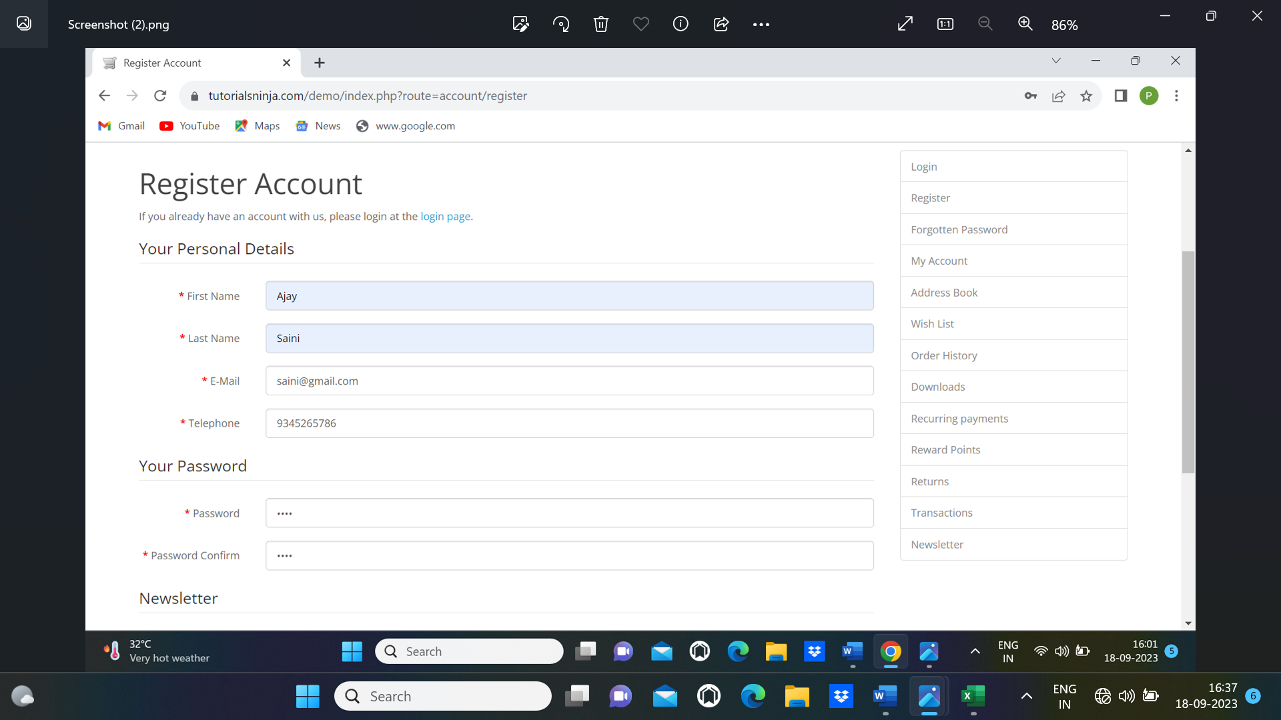

|  |  |  |
| --- | --- | --- |
| Submit | Clear | Cancel |